**HTML ASSIGNMENTS (TO PS)**

* Define the terms: Website, Web page, Web browser, Web server, HTML, CSS

**Website:**A **website** (also written as **web site**) is a collection of [web pages](https://en.wikipedia.org/wiki/Web_page" \o "Web page) and related content that is identified by a common [domain name](https://en.wikipedia.org/wiki/Domain_name" \o "Domain name) and published on at least one [web server](https://en.wikipedia.org/wiki/Web_server" \o "Web server). Examples of notable websites are [Google](https://en.wikipedia.org/wiki/Google_Search" \o "Google Search), [Facebook](https://en.wikipedia.org/wiki/Facebook" \o "Facebook), [Amazon](https://en.wikipedia.org/wiki/Amazon_(website)" \o "Amazon (website)), and [Wikipedia](https://en.wikipedia.org/wiki/Wikipedia" \o "Wikipedia).

**Web page :** Web page is a [hypertext](https://en.wikipedia.org/wiki/Hypertext" \o "Hypertext) [document](https://en.wikipedia.org/wiki/Electronic_document" \o "Electronic document) on the [World Wide Web](https://en.wikipedia.org/wiki/World_Wide_Web" \o "World Wide Web). Web pages are delivered by a [web server](https://en.wikipedia.org/wiki/Web_server" \o "Web server) to the [user](https://en.wikipedia.org/wiki/User_(computing)" \o "User (computing)) and displayed in a [web browser](https://en.wikipedia.org/wiki/Web_browser" \o "Web browser). A [website](https://en.wikipedia.org/wiki/Website" \o "Website) consists of many web pages [linked](https://en.wikipedia.org/wiki/Hyperlink" \o "Hyperlink) together under a common [domain name](https://en.wikipedia.org/wiki/Domain_name" \o "Domain name). The name "web page" is a metaphor of [paper pages](https://en.wikipedia.org/wiki/Page_(paper)" \o "Page (paper)) bound together into a [book](https://en.wikipedia.org/wiki/Book" \o "Book).

**Web browser:** Web Browser is [application software](https://en.wikipedia.org/wiki/Application_software" \o "Application software) for accessing the [World Wide Web](https://en.wikipedia.org/wiki/World_Wide_Web" \o "World Wide Web) or a local website. When a [user](https://en.wikipedia.org/wiki/User_(computing)" \o "User (computing)) requests a [web page](https://en.wikipedia.org/wiki/Web_page" \o "Web page) from a particular [website](https://en.wikipedia.org/wiki/Website" \o "Website), the web browser retrieves the necessary content from a [web server](https://en.wikipedia.org/wiki/Web_server" \o "Web server) and then displays the page on the user's device.

**Web server :** is [computer](https://en.wikipedia.org/wiki/Computer" \o "Computer) [software](https://en.wikipedia.org/wiki/Software" \o "Software) and underlying [hardware](https://en.wikipedia.org/wiki/Computer_hardware" \o "Computer hardware) that accepts requests via [HTTP](https://en.wikipedia.org/wiki/Hypertext_Transfer_Protocol" \o "Hypertext Transfer Protocol) (the [network protocol](https://en.wikipedia.org/wiki/Network_protocol" \o "Network protocol) created to distribute [web content](https://en.wikipedia.org/wiki/Web_content" \o "Web content)) or its secure variant [HTTPS](https://en.wikipedia.org/wiki/HTTPS" \o "HTTPS). A user agent, commonly a [web browser](https://en.wikipedia.org/wiki/Web_browser" \o "Web browser) or [web crawler](https://en.wikipedia.org/wiki/Web_crawler" \o "Web crawler), initiates communication by making a request for a [web page](https://en.wikipedia.org/wiki/Web_page" \o "Web page) or other [resource](https://en.wikipedia.org/wiki/Web_Resource" \o "Web Resource) using HTTP, and the [server](https://en.wikipedia.org/wiki/Server_(computing)" \o "Server (computing)) responds with the content of that resource or an [error message](https://en.wikipedia.org/wiki/List_of_HTTP_status_codes" \o "List of HTTP status codes). A web server can also accept and store resources sent from the user agent if configured to do so.

**HTML :** The **Hyper Text Markup Language** or **HTML** is the standard [markup language](https://en.wikipedia.org/wiki/Markup_language" \o "Markup language) for documents designed to be displayed in a [web browser](https://en.wikipedia.org/wiki/Web_browser" \o "Web browser). It can be assisted by technologies such as [Cascading Style Sheets](https://en.wikipedia.org/wiki/Cascading_Style_Sheets" \o "Cascading Style Sheets) (CSS) and [scripting languages](https://en.wikipedia.org/wiki/Scripting_language" \o "Scripting language) such as [JavaScript](https://en.wikipedia.org/wiki/JavaScript" \o "JavaScript).

**Cascading Style Sheets** (**CSS**) : CSS is a [style sheet language](https://en.wikipedia.org/wiki/Style_sheet_language" \o "Style sheet language) used for describing the [presentation](https://en.wikipedia.org/wiki/Presentation_semantics" \o "Presentation semantics) of a document written in a [markup language](https://en.wikipedia.org/wiki/Markup_language" \o "Markup language) such as [HTML](https://en.wikipedia.org/wiki/HTML" \o "HTML). CSS is a cornerstone technology of the [World Wide Web](https://en.wikipedia.org/wiki/World_Wide_Web" \o "World Wide Web), alongside HTML and [JavaScript](https://en.wikipedia.org/wiki/JavaScript" \o "JavaScript).

* Create a web page to show “This is my first HTML page!

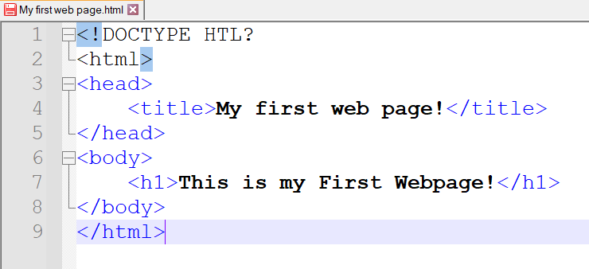

Output:

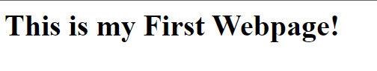

* Display top 10 IT companies list in html webpage

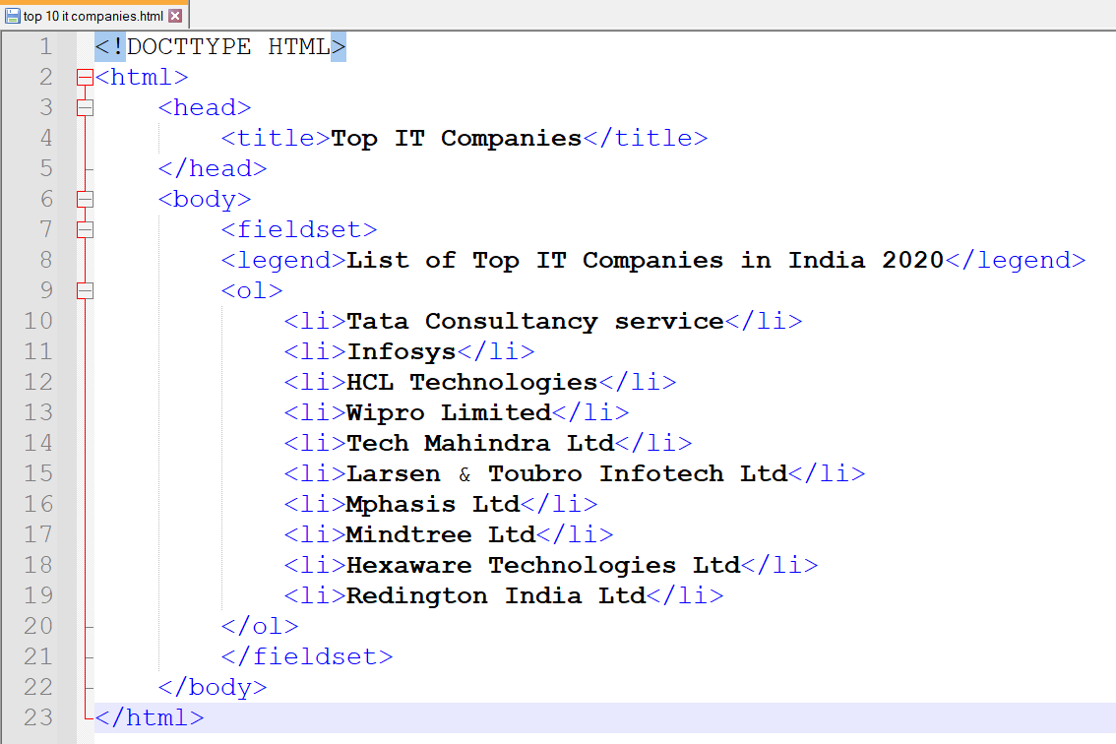

Output:

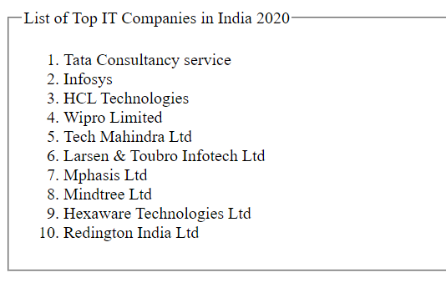

* Create a Table Of college Management system using row span & col span

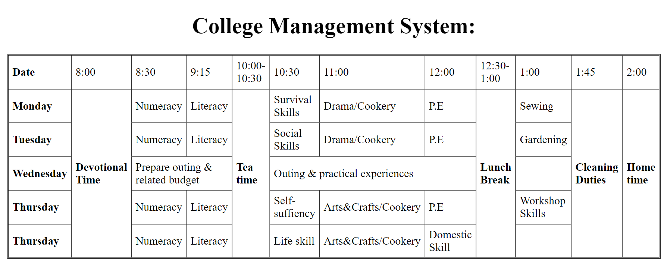

* • Create below table using HTML table tags

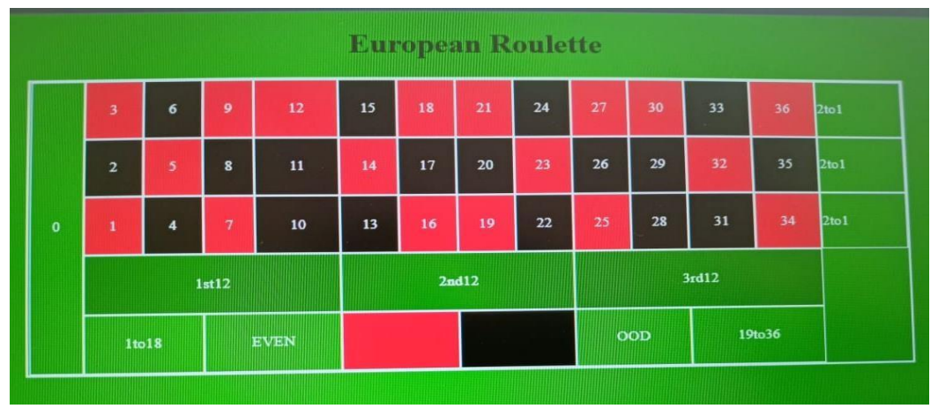

Output:

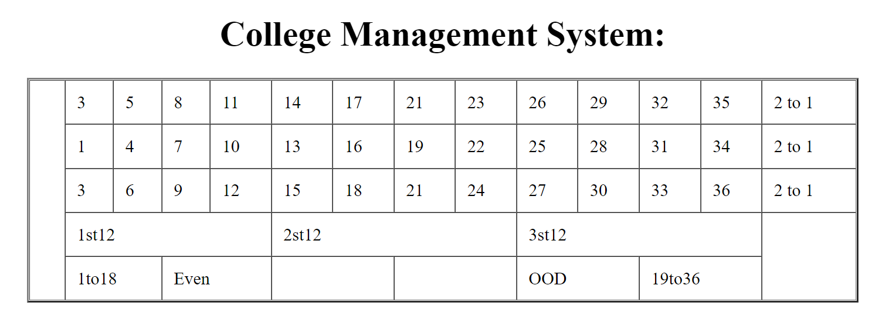

* Create Registration form using HTML, CSS

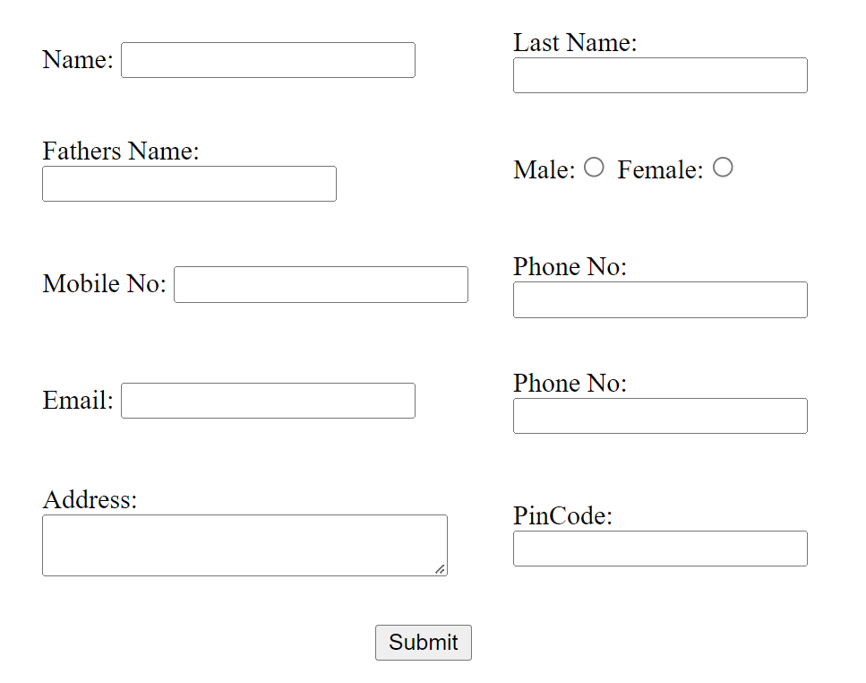

* In how many ways can a CSS be integrated as a web page?

Ans: CSS can be integrated in three ways, they are:

1. Inline CSS
2. Internal CSS
3. External CSS

* Create simple three pages using External CSS, Internal CSS, and Inline CSS.

Inline CSS:

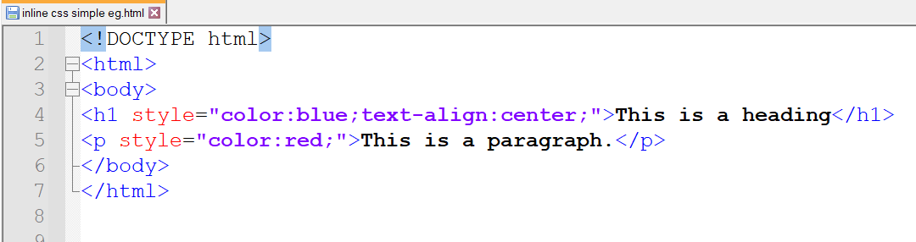

Output:

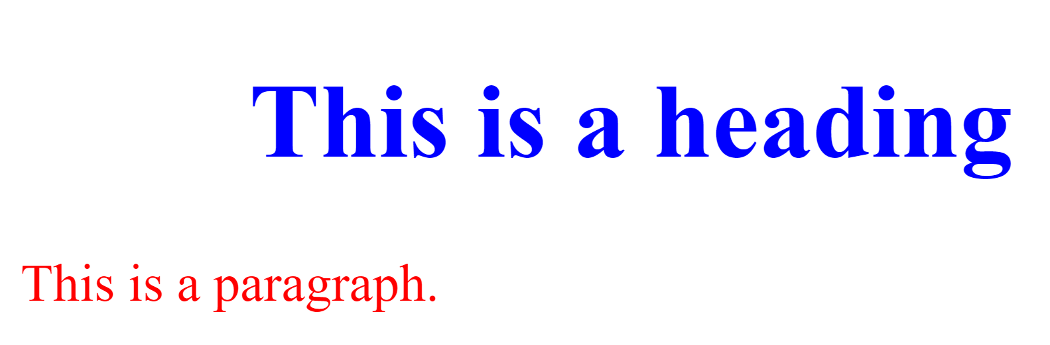

Internal CSS:

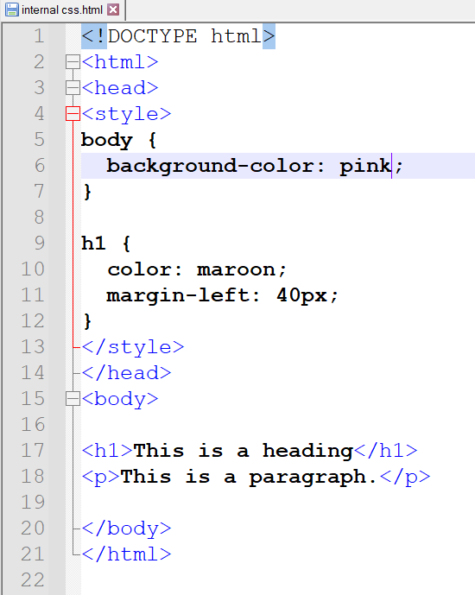

Output:

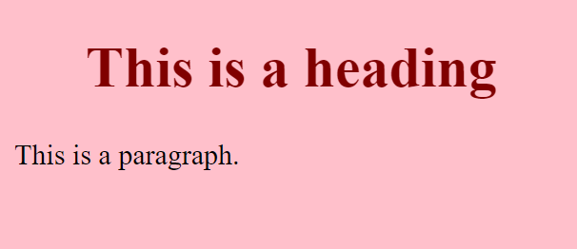

External CSS:

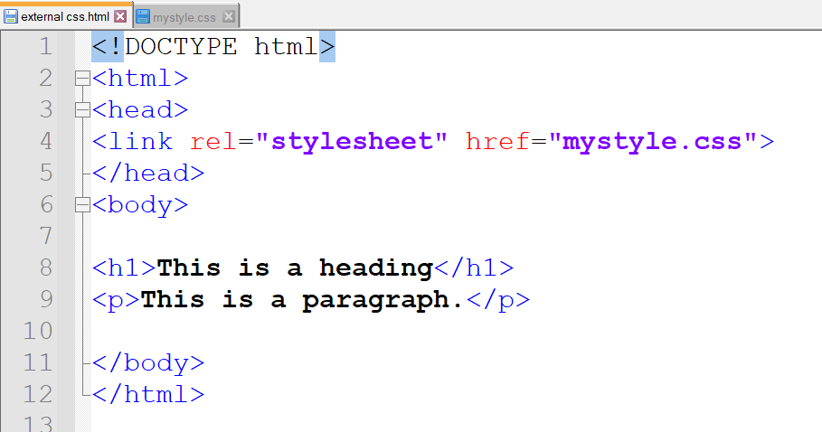

External Css (mystyle.css)

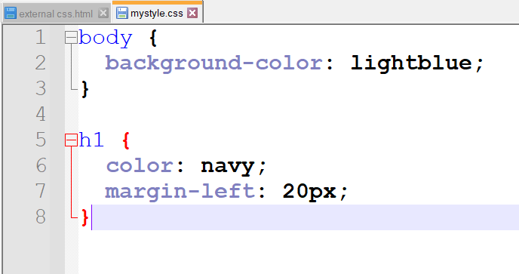

Output:

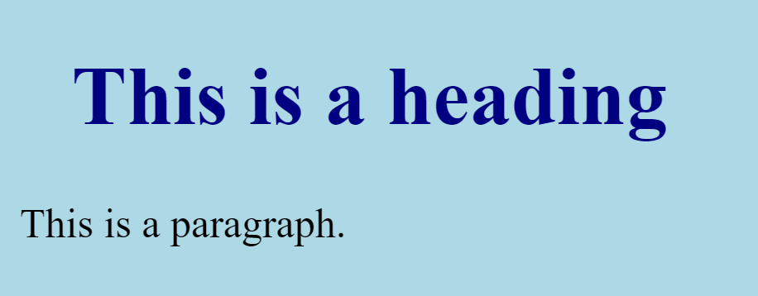

* Create below page using HTML CSS.

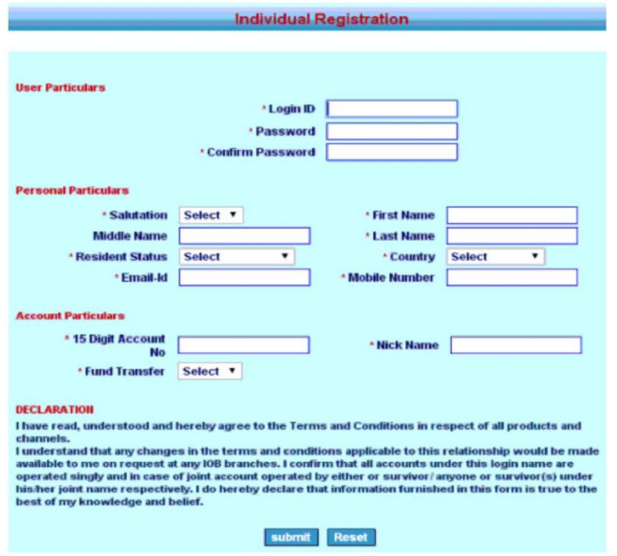

Output:

